5] (A)
#include <stdio.h>
#define SIZE 20
int q1[SIZE], q2[SIZE];
int front1=-1, rear1=-1, front2=-1, rear2=-1;
void enqueue1(int x){ if(rear1==SIZE-1) return; if(front1==-1) front1=0; q1[++rear1]=x; }
int dequeue1(){ if(front1==-1||front1>rear1) return -1; return q1[front1++]; }
void enqueue2(int x){ if(rear2==SIZE-1) return; if(front2==-1) front2=0; q2[++rear2]=x; }
int dequeue2(){ if(front2==-1||front2>rear2) return -1; return q2[front2++]; }
void push(int x){
enqueue2(x);
while(front1!=-1 && front1<=rear1){
enqueue2(dequeue1()); }
int *f1=&front1,*r1=&rear1,*f2=&front2,*r2=&rear2;
int t;
t=*f1;*f1=*f2;*f2=t;
t=*r1;*r1=*r2;*r2=t;
for(int i=0;i<SIZE;i++){ t=q1[i];q1[i]=q2[i];q2[i]=t; }}
int pop(){
if(front1==-1||front1>rear1) return -1;
return dequeue1(); }
int main(){
push(10); push(20); push(30);
printf("Popped: %d\n",pop());
printf("Popped: %d\n",pop());
return 0; }
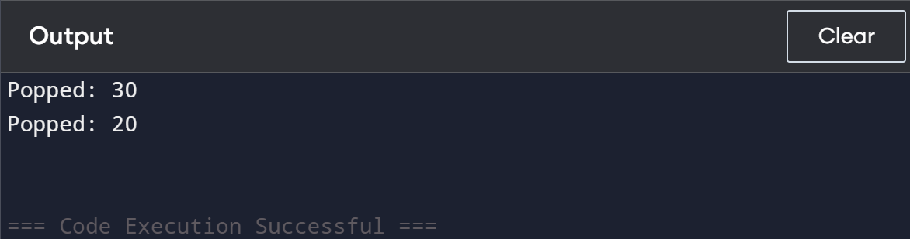

(B)
#include <stdio.h>
#define SIZE 20
int q[SIZE], front=-1, rear=-1;
void enqueue(int x){ if(rear==SIZE-1) return; if(front==-1) front=0; q[++rear]=x; }
int dequeue(){ if(front==-1||front>rear) return -1; return q[front++]; }
void push(int x){
enqueue(x);
int sz = rear - front;
while(sz--){
enqueue(dequeue()); }}
int pop(){
if(front==-1||front>rear) return -1;
return dequeue(); }
int main(){
push(5); push(15); push(25);
printf("Popped: %d\n",pop());
printf("Popped: %d\n",pop());
return 0; }
